**CHAPTER THREE**

**Methodology and Design**

**3.1 Introduction**

A methodology is a rigorous study or inquiry, particularly to unearth new facts or information; thus, research methodology should be good enough to enable the achievement of the specified objectives, which are achievable using specific components, such as data collection and design procedures, and system modeling (use case, activity, and class diagrams). This chapter provides the input/output specifications as well as the system requirements for developing a **web-based student examination result complaint system**.

**3.2 Methods of Data Collection**

Before constructing any system, it is necessary to collect data and facts about the existing system to comprehend what is going on. Two approaches were used in this study.

1. Primary Source
2. Secondary Source

**3.2.1 Primary Source of Information**

This includes data gathered directly or indirectly from target users, with no edits or suggestions from other writers. This main source's material is considered more accurate and credible. As a result, the goal is to incorporate the knowledge gleaned from this source into the project to satisfy the criteria. Interviews and observations were used as primary source data collection strategies.

**3.2.2 Secondary Source of Information**

This essentially includes all of the information that someone can receive from existing sources such as books, the internet, case studies, articles, newsletters, and other relevant publications. The resources obtained from the internet in particular were quite relevant; various search engines, particularly Google, made it very easy to find information.

**3.3 System Modeling**

A system model is a conceptual model of a system that explains and depicts it. A system is any interaction between a group of components that work together to achieve a common purpose. A collection of visual notation techniques inherent in the Unified Modeling Language, which was used to design this current system, may be used to construct visual models of object-oriented software-intensive systems. UML diagrams utilized in this new design include use case diagrams, class diagrams, and activity diagrams.

**3.3.1 Use Case Diagrams**

Use cases are groups of interactions between a system and a user. Use case diagrams are used to graphically portray the functioning of a system in terms of its actors, goals (expressed as use cases), and dependencies between those use cases.

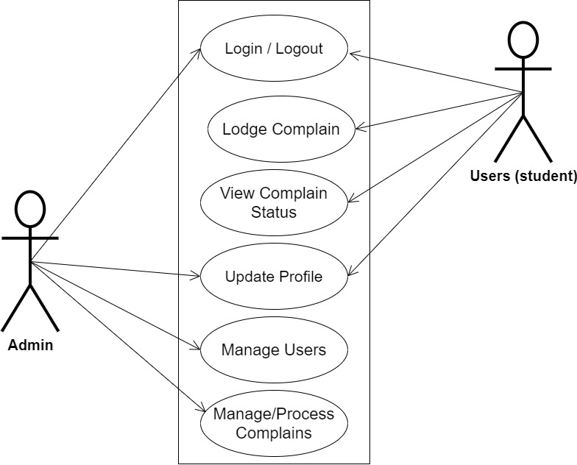

**Fig 3.1 System Use Case Diagram**

**3.3.2 Class Diagrams**

The Unified Modeling Language (UML) class diagram is an implementation of an independent view of how the system interface might appear, with each class having its own set of properties and displaying how they interact with one another. Class diagrams use the Unified Modeling Language standards to visually depict a given system's static structure and composition (UML).

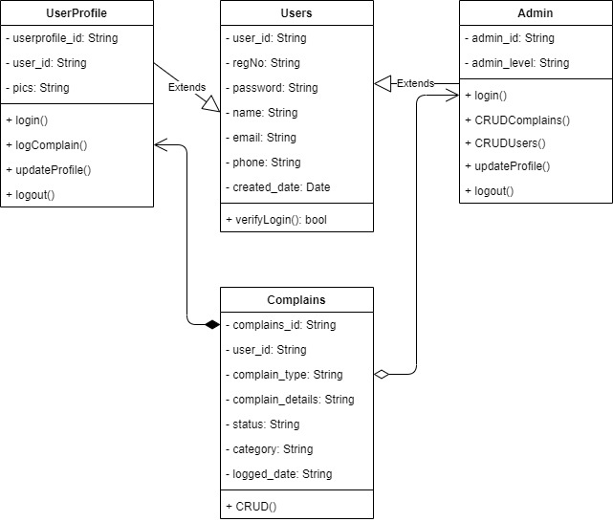

**Fig 3.2 System Class Diagram**

**3.3.3 Activity Diagrams**

An activity diagram, like a flowchart or a data flow diagram, visually illustrates a series of events or the flow of control in a system, but it acts more like an enhanced version of both.

**Login**

The process for gaining access to the system is depicted in the diagram below; the email address and password must be accurate to gain access.

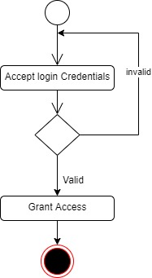

**Fig 3.3.1 Login Activity Diagram**

**Lodging Complain**

The process for filing a complaint is depicted below, to create a complaint one has to be authenticated to lodge a complain.

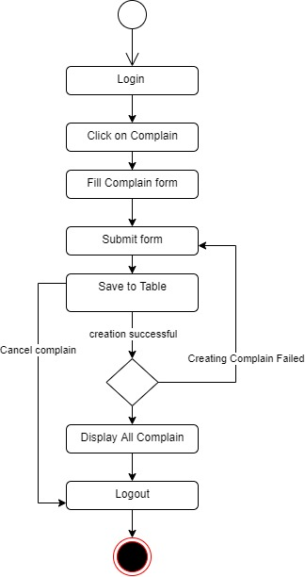

**Fig 3.3.2 Lodging Complain Activity Diagram**

**3.4 Database Design**

Input specification is the logical explanation of how data is stored in the computer's memory. SQL standards are vital for guaranteeing that structured data is uniform and independent of applications due to the flexibility experienced when using the system, as well as the simplicity of accessing and reading the data and ensuring applicability throughout the internet. The following are some of the input specifications used in this project effort.

1. Users Table: contains basic information about all system users.
2. Complain Table: contains every system-saved complaint information.

**Table 3.1 Users Input Specification Table**

|  |  |  |  |  |  |
| --- | --- | --- | --- | --- | --- |
| **Field Name** | **Data Type** | **Null** | **Key** | **Length** | **Description** |
| user_id | Varchar | No | PK | 32 | Unique string for identifying users |
| regNo | Varchar | No |  | 14 | User Registration number |
| password | Varchar | No |  | 128 | User Password |
| name | Varchar | No |  | 100 | User full name |
| email | Varchar | No |  | 100 | User email address |
| phone | Varchar | No |  | 11 | User phone number |
| created_date | Varchar | No |  | 10 | Account created date |

**Table 3.2 Complain Input Specification Table**

|  |  |  |  |  |  |
| --- | --- | --- | --- | --- | --- |
| **Field Name** | **Data Type** | **Null** | **Key** | **Length** | **Description** |
| complain_id | Varchar | No | PK | 32 | Unique string identifying notice |
| user_id | Varchar | No | FK | 32 | Reference to the user account |
| complain_type | Varchar | No |  | 255 | Type of the complaint |
| complain_details | Varchar | No |  | 255 | Detail description of the complain |
| status | Varchar | No |  | 20 | Status of the complaint |
| category | Double | No |  | 20 | Category of the complaint |
| logged_date | Date | No |  | 10 | Date the complaint was logged |

**3.5 Output Design**

This declares and displays the outcome of the given input. This automated system's output is dependent on its input. The output specification is listed below.

**Table 3.3 Users** **output design table**

|  |  |  |  |  |  |
| --- | --- | --- | --- | --- | --- |
| **User_id** | **regNo** | **Name** | **Email** | **Phone** | **Created_date** |
| XXXX | XXXX | XXXX | XXXX | XXXX | XXXX |
| XXXX | XXXX | XXXX | XXXX | XXXX | XXXX |
| XXXX | XXXX | XXXX | XXXX | XXXX | XXXX |
| XXXX | XXXX | XXXX | XXXX | XXXX | XXXX |

**Table 3.4 Complain** **output design table**

|  |  |  |  |  |  |  |
| --- | --- | --- | --- | --- | --- | --- |
| **Complain_id** | **User_id** | **Complain_type** | **Complain_details** | **Status** | **Category** | **Logged_date** |
| XXXX | XXXX | XXXX | XXXX | XXXX | XXXX | XXXX |
| XXXX | XXXX | XXXX | XXXX | XXXX | XXXX | XXXX |
| XXXX | XXXX | XXXX | XXXX | XXXX | XXXX | XXXX |
| XXXX | XXXX | XXXX | XXXX | XXXX | XXXX | XXXX |

**3.6 Input & User Interface Design**

This is a graphic depiction of the system interface; it will be designed to be user-friendly, responsive, and visually beautiful. Furthermore, it will be fully secured, thus authentication will be required to see various levels of the information. To help with the designs, a mid-fidelity wireframing program called Draw.io is employed.

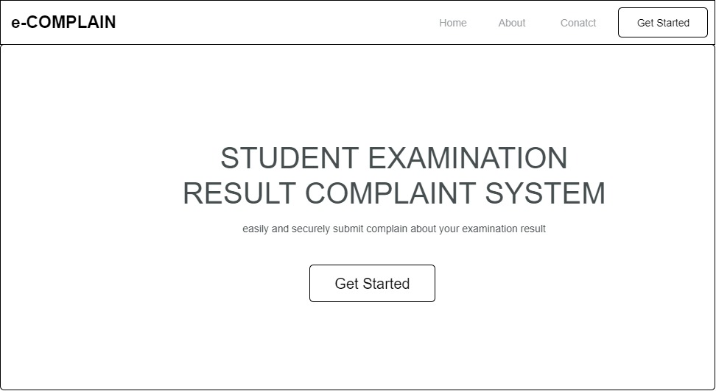

**Fig 3.6.1 Home Page**

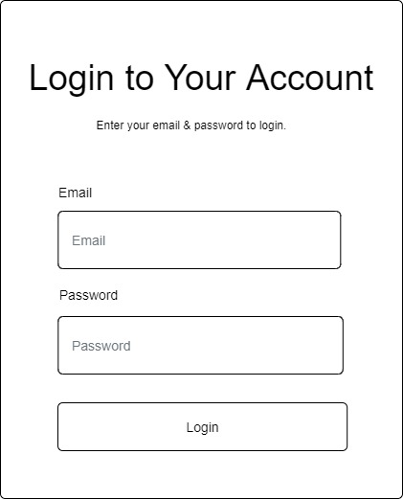

**Fig 3.6.2 Login Page**

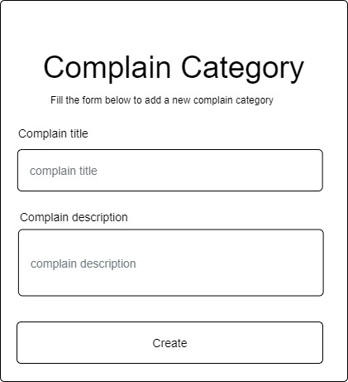

**Fig 3.6.3 Create Complain Category Form**

**3.7 System Requirement**

Every piece of software-generated has predefined system requirements that it must fulfill to function properly. The system requirements, on the other hand, are the bare minimum of hardware and software required for the system's intended operation.

**3.7.1 Hardware Requirement**

System Hardware Requirement Include:

1. Minimum of 2 GB of RAM (Random Access Memory).
2. Minimum of Intel Dual core processor.
3. Minimum of 250GB HDD (Hard Disk Drive).

**3.7.2 Software Requirement**

The software requirements include:

1. At least windows 7 OS (Operating System).
2. Vs. Code IDE installation.
3. Browsers include Chrome and Firefox.

**3.8 Choice of Programming Language**

This study will be a web-based application based on the design of a relational database (SQLite). HTML (hypertext markup language), CSS (cascading style sheet), and JavaScript will be utilized for front-end development, while Django (Python) will be used for back-end programming.